MA105G.04
1 of 20
What is g(x) = f⁻¹(x) if f(x) = x?
g(x) = 0
g(x) = -2x
g(x) = x⁻¹
g(x) = 2x

2 of 20
Which common graph looks like a really wide, short "S"?
Cubic
Square root
5th order polynomial
Cube root

3 of 20
Determine which two function are inverses of each other.
f(x) |  | = |  | x+2  4 |  | g(x)= 4x + 2 h(x) = |  | x-2  4
f(x) and h(x)
f(x) and g(x)
g(x) and h(x)
None

4 of 20
J(x) = x ⁻¹ is an example of:
an inverse function.
a constantly diminishing function.
x ≠ 0.
a linear function with negative slope.
5 of 20
Which of the following is a reflection of f(x) = -x + 1 about the x-axis?
r(x) = x + 1
r(x) = x - 1
r(x) = -( x - 1)
None of the above

6 of 20
(f ° g)(x) = (g ° f)(x)
Always
Never
Sometimes
There is no such thing as (f ° g)(x)

7 of 20
Find the domain of the function
f(x) |  | = |  | 1  x-6 |  | + |  | 4  x+7
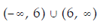
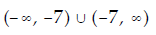

8 of 20
Consider d(x) = (x + 2)³ + 3; what is the new equation for d(x) if it is 4 times larger?
d(x) = 4(x + 2)³ + 12
d(x) = (x + 2)¹² + 3
d(x) = 4(x + 2)³
d(x) = 4(x + 2)³ + 3

9 of 20
Which of the following is a translated version of f(x) = x³?
f(x) = x³ + 1
f(x) = (x - 12)³
f(x) = (x - 12)³ + 1
All of the above

10 of 20
If g(x) = 3f(x) and f(13) = 12, then g(13) =
36
39
-9
This cannot be determined based on the given information.

11 of 20
Consider f(x) = x²; s(x) is f(x) shifted which way and how far, if
s(x) = (x + 2)² - 3?
To the left 4 units
To the right 2 units
To the left 3 units
To the left 2 units

12 of 20
Begin by graphing the standard quadratic function f(x) = x^{2.} Then use transformatios of this graph to graph the given function.
h(x) = (x-7)² + 7
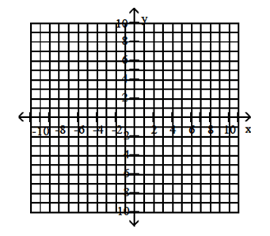
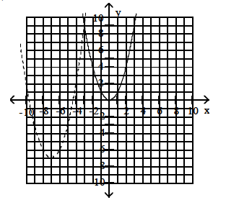
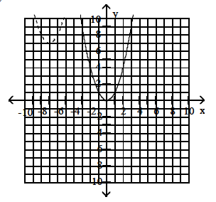
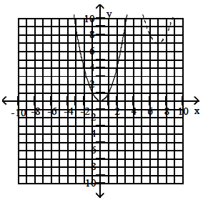
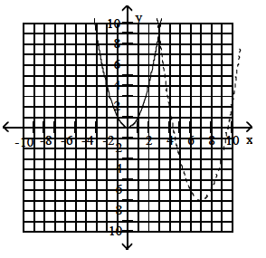

13 of 20
Find the distance between the pair of points.
(-2, -6) and (7, -3)
6
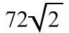
72
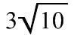

14 of 20
Which common graph represents a horizontal line?
The constant function
The identity function
The inverse function
None of the above, horizontal lines are not functions

15 of 20
If g(x) is an inverse of f(x), then how do the x-values and y-values coordinates of the points on f(x) map onto coordinates of g(x)?
The ordinate values in f(x) become the x-values values in g(x), and the x-values values in f(x) becomes the ordinate values in g(x)
They swap roles
Both (A) and (B)
Neither (A) nor (B)

16 of 20
As x gets arbitrarily large in a negative way, k(x) = x⁻² approaches:
∞
-∞
0
You cannot take the square root of a negative quantity

17 of 20 Complete the square and write the equation in standard form. Then give the center and radius of the circle.
x² ⁺ y² - 2x - 4y - 4 = 0
(x + 1)² + (y + 2)² = 9
(-1, -2), r = 3
(x - 1)² + (y - 2)² = 9
(-1, -2), r = 3
(x - 1)² + (y - 2)² = 9
(1, 2), r = 9
(x - 1)² + (y - 2)² = 9
(1, 2), r = 3

18 of 20
Consider g(x) = (x + 2)³ + 3; what is the new equation for g(x) if it is shifted up 6 units and shifted right 9 units?
g(x) = (x + 11)³ + 6
g(x) = (x + 2)³ - 3
g(x) = (x - 7)³ + 9
It is still g(x) = (x + 2)³ + 3
19 of 20
If f(g(x)) = g(f(x)) = x, then what can we say about f(x) and g(x)?
They are functional inverses of each other
f(x) = g(x)
f(x) = g(x) = x
Nothing can be said about f(x) and g(x)
20 of 20
What is f(x) if f(x) = z(x) + 2 and z(x) = 2x - 3?
f(x) = z(x) - 1
f(x) = z(x) + 2x - 1
f(x) = 2x - 1
This cannot be solved.

